Neural Mechanisms of Tool Use in Corvids
Tool use could be thought of as the ability to use one object to manipulate another object in order to achieve a goal (Olmstead & Kuhlmeier, 2015). Several species of the Corvid family have demonstrated tool use abilities. For example, New Caledonian crows can use sticks to extract food from places that they can not reach. Moreover, they can also manufacture hooked tools out of pandanus leaves for food extraction (Hunt, Lambert, & Gray, 2007). Also, ravens have demonstrated the ability to pull strings to collect food (Heinrich & Bugnyar, 2005). Correlational evidence suggests that overall brain size and the size of neostriatum is associated with tool using behaviour in a bird species (Lefebvre et al, 2002). Neostriatum in birds was later renamed as nidopallium (Jarvis et al, 2005). Part of nidopallium called the nidopallium caudolaterale is analogous to prefrontal cortex in mammals because both of these brain regions support executive functions (Güntürkün, 2005). Executive functions are a set of behaviours that allow an individual to execute plans (Güntürkün, 2005). Executive functions can be involved in tool use because tools in birds are used with the goal of extracting food among other things so, tool use can be considered a goal directed behaviour. Causal evidence for neural mechanisms that support tool use has been limited. Finding out the neural mechanisms of tool use in corvids is important because it helps us understand the mechanisms of convergent evolution of tool use by making comparisons with humans and other tool using primates. We hypothesize that nidopallium caudolaterale will be causally involved in a bird’s tool using behaviour as previous studies have found that it is significantly larger in tool using birds and it supports executive functioning (Boire et al, 2002, Güntürkün, 2005).
We propose a within-group design where a sample of crows that belong to a specie are brought into a place. There is food placed behind bars in a box such that a crow can not reach the food with its beak. There are many sticks placed on the floor, each of different size. If a crow can find the right sized stick from the floor and use it to retrieve the food from the box, it will index tool using behaviour. This task is done for each crow over at least 25 trials in two conditions: an experimental condition and a control condition. In the control condition, the crows perform this task as it is mentioned above. In the experimental condition, the nidopallium caudolaterale is surgically lesioned in the crows and then the same task is given. The dependent variable is the instances of retrieval of food using a stick while the independent variable is the presence of lesion. If nidopallium caudolateral lesion significantly reduces the number of instances the crows used the tool to retrieve food, it would suggest that nidopallium caudolaterale is causally involved in tool using. Conversely if the lesion does not reduce the instances of tool use, it would suggest that nidopallium caudolaterale is not causally involved in tool using behaviour.
We expect the results to be consistent with our hypothesis. Our hypothesis predicts that there would be a significant reduction in tool use after nidopallium caudolaterale lesion. Hence, we expect that the number of instances of food retrieval using sticks would significantly decrease after the nidopallium caudolateral is lesioned (Figure 1).
In general, previous research shows that there is a positive correlation between nidopallium area and tool using behaviour in birds. We hypothesize that part of nidopallium that is associated with executive functioning and is analogous to mammalian prefrontal cortex, will be causally involved in tool using behaviour in birds. Hence, we came up with a study design to test it. We expect that if a lesion is induced on the nidopallium caudolaterale, the birds will exhibit tool use deficit which will show that tool using behaviour depends on nidopallium caudolaterale. The next steps for future research would be finding specific genes and epigenetic mechanisms that further mediate the relationship between nidopallium caudolaterale and tool using behaviour. This would further our understanding of how a species evolves tool using behaviour and how it evolved in humans.

Figures
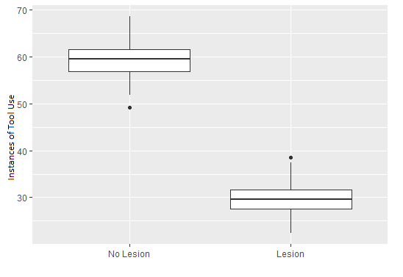
Figure 1: The expected results. The birds’ instances of using tools to retrieve food will significantly decrease if a lesion is induced on the nidopallium caudolaterale.

References
G. R. Hunt, C. Lambert & R. D. Gray (2007) Cognitive requirements for tool use by New
Caledonian crows (Corvus moneduloides), New Zealand Journal of Zoology, 34:1, 1-7, DOI: 10.1080/03014220709510058
Güntürkün, O. (2005). The avian 'prefrontal cortex' and cognition. Current Opinion in
Neurobiology, 15(6), 686-693. doi:http://dx.doi.org/10.1016/j.conb.2005.10.003
Heinrich, B., & Bugnyar, T. (2005). Testing problem solving in ravens: String-pulling to reach
food. Ethology, 111(10), 962-976. doi:http://dx.doi.org/10.1111/j.1439-0310.2005.01133.x
Jarvis, E., Güntürkün, O., Bruce, L. et al. Avian brains and a new understanding of vertebrate
brain evolution. Nat Rev Neurosci 6, 151–159 (2005). https://doi.org/10.1038/nrn1606
Lefebvre, L., Nicolakakis, N., & Boire, D. (2002). Tools and brains in birds. Behaviour, 139(7),
939-973. doi:http://dx.doi.org/10.1163/156853902320387918
Olmstead, M., & Kuhlmeier, V. (2015). Comparative Cognition. Cambridge: Cambridge
University Press. doi:10.1017/CBO9780511894787

